**Ideation Phase**

**Empathize & Discover**

|  |  |
| --- | --- |
| Date | 01 July 2025 |
| Team ID | LTVIP2025TMID40229 |
| Project Name | Hematovision |
| Maximum Marks | 4 Marks |

**Empathy Map Canvas:**

Empathy Map Canvas for HematoVision: Advanced Blood Cell Classification, tailored primarily for the target user — *pathologists, lab technicians, medical students, and healthcare providers* using or interacting with the system.

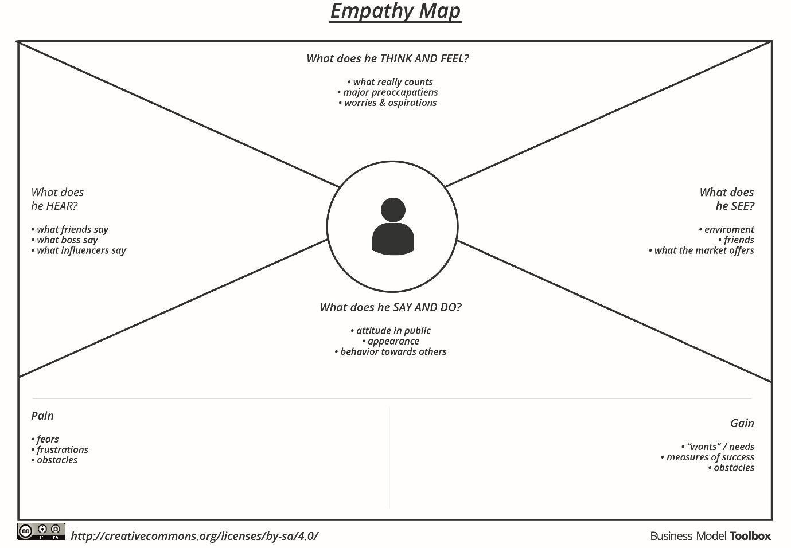

**Hematovision Application:**

